Lab 9

Isaiah Hoffer

\*I wasn’t 100% sure if I was supposed to fix actual errors or make the code do something. Like in A I changed words and lines so it changed the text because it wouldn’t even if it was correctly written. Part B had the most changes, the first few said to match $2 with angle, but $2 is an # so I assumed it was supposed to be $3, but that is not the section case said to do so technically it wasn’t wrong, just not helpful. \*

LAB Q A1

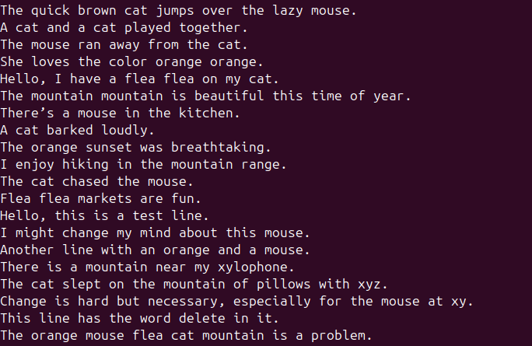

LAB Q A2

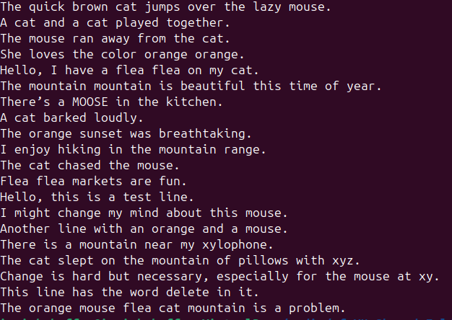

LAB Q A3

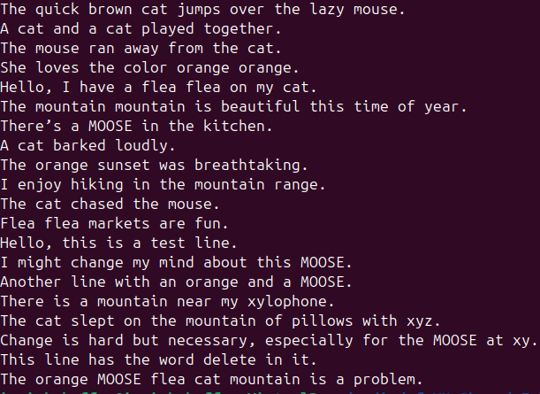

LAB Q A4

Changed from line 10 to line 9

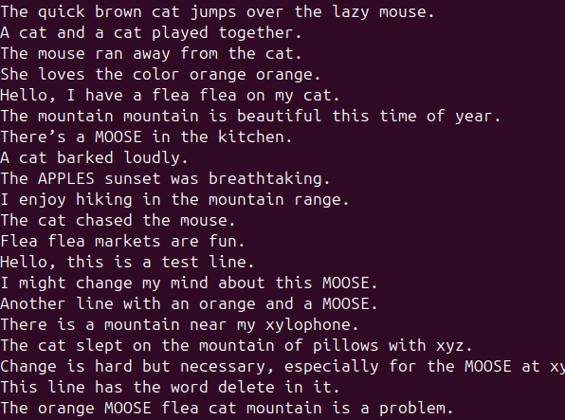

LAB Q A5

Replace hello with Hello

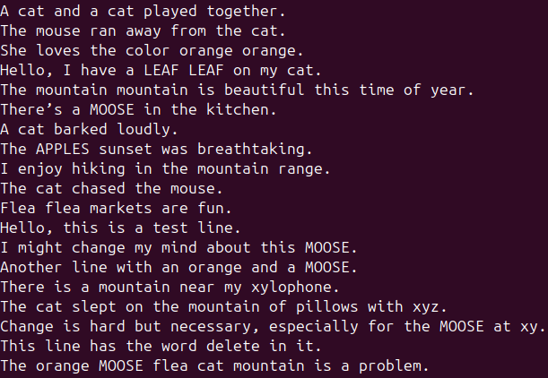

LAB Q A6

Change begins with ‘the’ and change end with ‘problem’

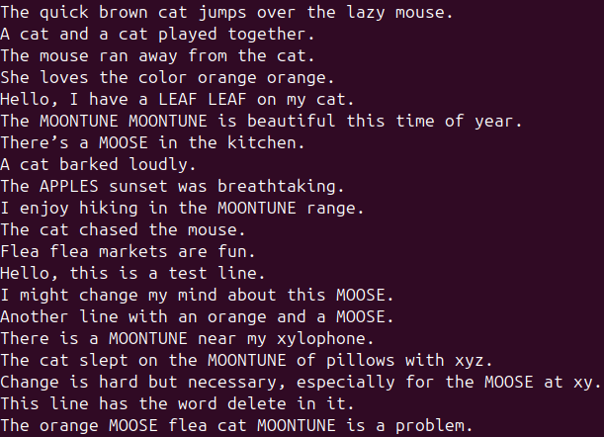

LAB Q A7

Wrong Syntax: /change/c\I am different now

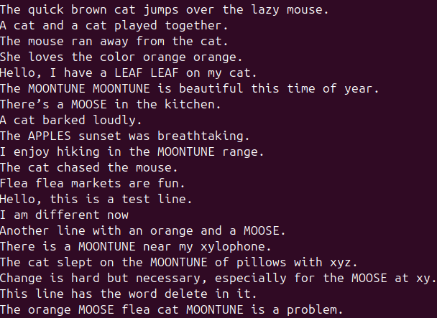

Accidentally skipped this question, so that’s why the other screenshots still have

“I might change my mind about this MOOSE” instead of “I am different now”

LAB Q A8

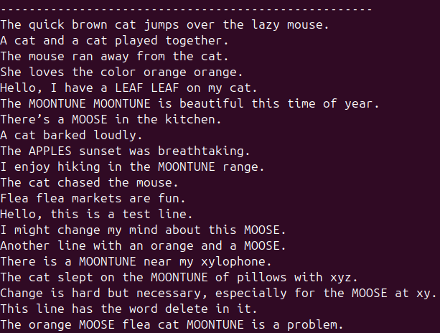

LAB Q A9

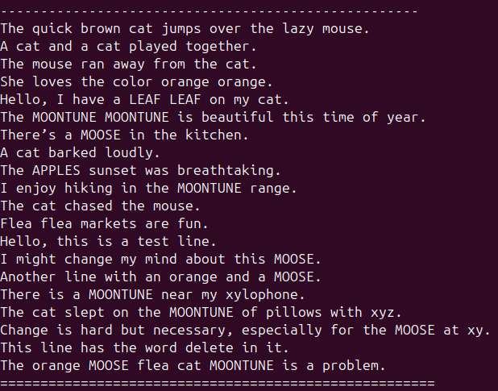

LAB Q A10

Syntax wrong, change to 1,15{s/x/!/g; s/y/#/g}

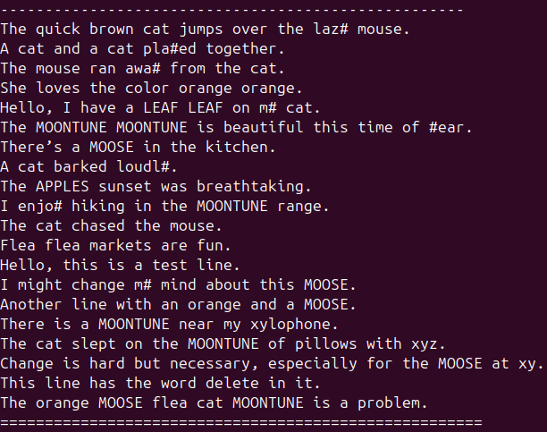

LAB Q A11

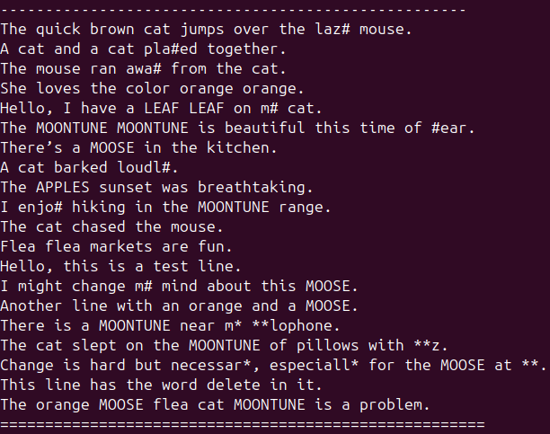

LAB Q A12

Either add s/\<LEAF LEAF\>/LEAF/g or replace flea flea for LEAF LEAF

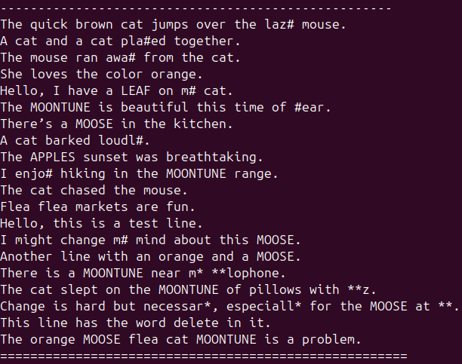

LAB Q A13

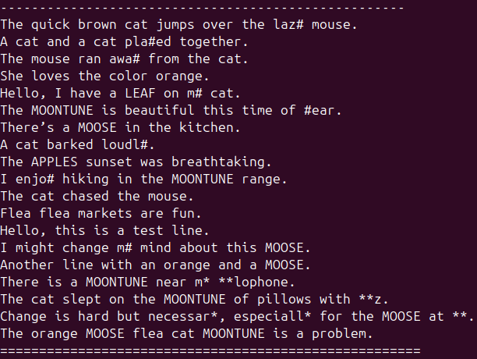

LAB Q A14

I wasn’t sure if it was supposed to be separate strings, because this doesn’t do anything, so if it was the code is /orange/d; /mouse/d; /flea/d; /cat/d; /mountain/d. I added both screenshots!

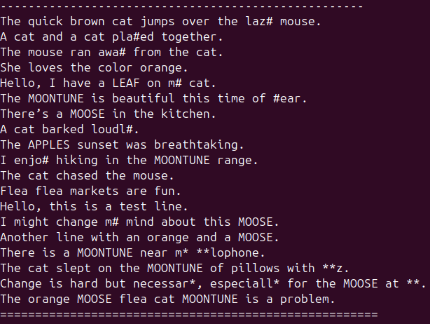

ALTERNATE A14 ANSWER:

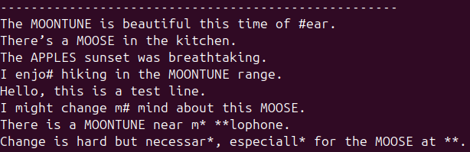

PART B:

LAB Q B1

Fixed: gawk 'tolower($1) ~ /[gG][rR]?[e][e]?[nN]/ && !/[E]/ { print $1, $3 }' test1.txt

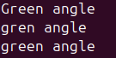

LAB Q B2

Fixed: gawk '$3 == "angle" { printf "%s %s\n", $3, $1 }' test1.txt

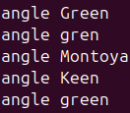

LAB Q B3

Fixed: gawk -v fieldA=3 -v fieldB=1, '$fieldA == "angle" { printf "%s %s\n", $fieldA, $fieldB }' test1.txt

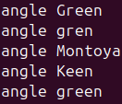

LAB Q B4

Fixed: gawk '$3 == "angle" && $4 == "OVA" { printf "%s %s\n", $3, $4 }' test1.txt



LAB Q B5

Fixed: gawk '$1 ~ /[kK][eE][yY][nN]+[0-9]+[nN]+[a-zA-Z]/ { printf "%.4s %.5s\n", $1, $3 }' test1.txt



LAB Q B6

Fixed: gawk '$4 == "mont" || $1 == "montoya" { print $3, $1 }' test1.txt



LAB Q B7

